[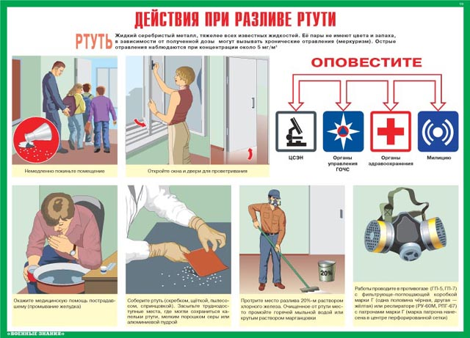](http://images.yandex.ru/yandsearch?source=wiz&uinfo=sw-1423-sh-805-fw-1198-fh-598-pd-1&p=2&text=%D0%BA%D0%B0%D1%80%D1%82%D0%B8%D0%BD%D0%BA%D0%B8%20%D0%BF%D0%BE%20%D1%87%D1%80%D0%B5%D0%B7%D0%B2%D1%8B%D1%87%D0%B0%D0%B9%D0%BD%D1%8B%D0%BC%20%D1%81%D0%B8%D1%82%D1%83%D0%B0%D1%86%D0%B8%D1%8F%D0%BC%20%D0%B4%D0%BB%D1%8F%20%D0%B4%D0%B5%D1%82%D0%B5%D0%B9&noreask=1&pos=89&rpt=simage&lr=54&img_url=http://babushkinsky.svao.mos.ru/common/upload/docs/Deystviya_pri_razlive_rtuti.jpg)

[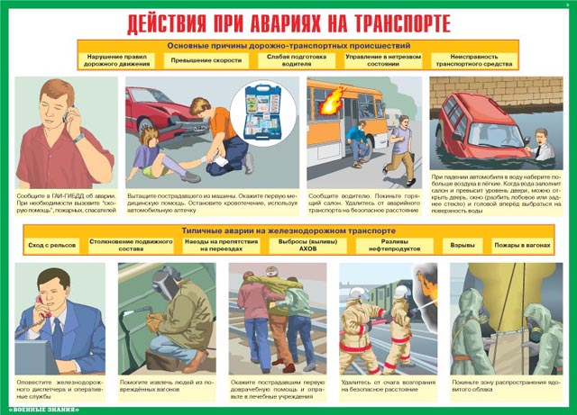](http://images.yandex.ru/yandsearch?source=wiz&uinfo=sw-1423-sh-805-fw-1198-fh-598-pd-1&p=3&text=%D0%BA%D0%B0%D1%80%D1%82%D0%B8%D0%BD%D0%BA%D0%B8%20%D0%BF%D0%BE%20%D1%87%D1%80%D0%B5%D0%B7%D0%B2%D1%8B%D1%87%D0%B0%D0%B9%D0%BD%D1%8B%D0%BC%20%D1%81%D0%B8%D1%82%D1%83%D0%B0%D1%86%D0%B8%D1%8F%D0%BC%20%D0%B4%D0%BB%D1%8F%20%D0%B4%D0%B5%D1%82%D0%B5%D0%B9&noreask=1&pos=102&rpt=simage&lr=54&img_url=http://www.66.mchs.gov.ru/upload/iblock/d68/d68bbdd4e90b47c5ae507b5c21e3765f.jpg)

[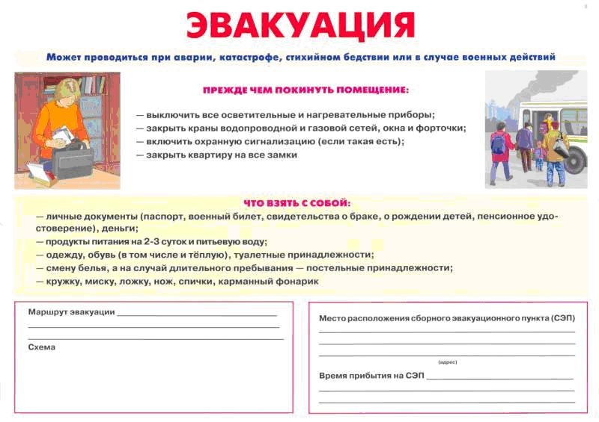](http://images.yandex.ru/yandsearch?source=wiz&uinfo=sw-1423-sh-805-fw-1198-fh-598-pd-1&p=3&text=%D0%BA%D0%B0%D1%80%D1%82%D0%B8%D0%BD%D0%BA%D0%B8%20%D0%BF%D0%BE%20%D1%87%D1%80%D0%B5%D0%B7%D0%B2%D1%8B%D1%87%D0%B0%D0%B9%D0%BD%D1%8B%D0%BC%20%D1%81%D0%B8%D1%82%D1%83%D0%B0%D1%86%D0%B8%D1%8F%D0%BC%20%D0%B4%D0%BB%D1%8F%20%D0%B4%D0%B5%D1%82%D0%B5%D0%B9&noreask=1&pos=117&rpt=simage&lr=54&img_url=http://kohma.ivanovoweb.ru/images/stories/News/evakuacia.jpg)

[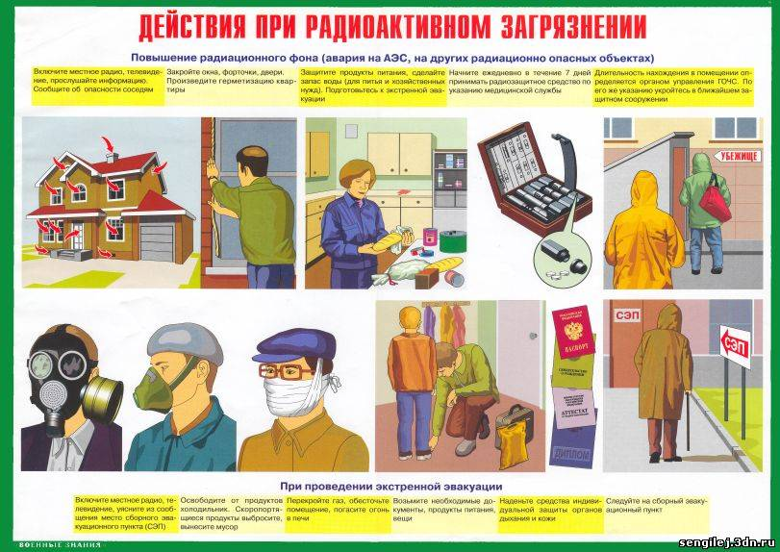](http://images.yandex.ru/yandsearch?source=wiz&uinfo=sw-1423-sh-805-fw-1198-fh-598-pd-1&p=7&text=%D0%BA%D0%B0%D1%80%D1%82%D0%B8%D0%BD%D0%BA%D0%B8%20%D0%BF%D0%BE%20%D1%87%D1%80%D0%B5%D0%B7%D0%B2%D1%8B%D1%87%D0%B0%D0%B9%D0%BD%D1%8B%D0%BC%20%D1%81%D0%B8%D1%82%D1%83%D0%B0%D1%86%D0%B8%D1%8F%D0%BC%20%D0%B4%D0%BB%D1%8F%20%D0%B4%D0%B5%D1%82%D0%B5%D0%B9&noreask=1&pos=210&rpt=simage&lr=54&img_url=http://www.45.mchs.gov.ru/upload/images/GO20.jpg)

[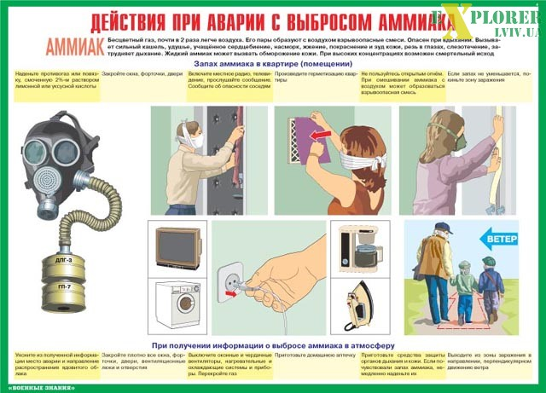](http://images.yandex.ru/yandsearch?source=wiz&uinfo=sw-1423-sh-805-fw-1198-fh-598-pd-1&p=7&text=%D0%BA%D0%B0%D1%80%D1%82%D0%B8%D0%BD%D0%BA%D0%B8%20%D0%BF%D0%BE%20%D1%87%D1%80%D0%B5%D0%B7%D0%B2%D1%8B%D1%87%D0%B0%D0%B9%D0%BD%D1%8B%D0%BC%20%D1%81%D0%B8%D1%82%D1%83%D0%B0%D1%86%D0%B8%D1%8F%D0%BC%20%D0%B4%D0%BB%D1%8F%20%D0%B4%D0%B5%D1%82%D0%B5%D0%B9&noreask=1&pos=220&rpt=simage&lr=54&img_url=http://www.gradremstroy.ru/wp-content/gallery/images_go/kompl1_04.jpg)

[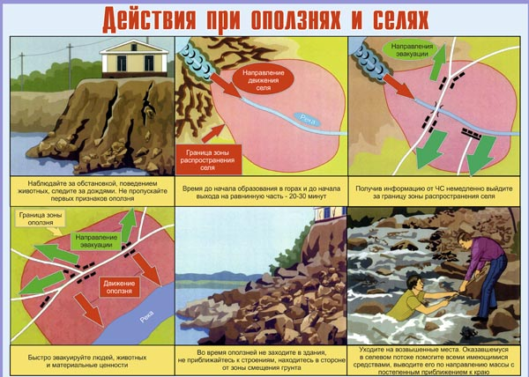](http://images.yandex.ru/yandsearch?text=%D0%BA%D0%B0%D1%80%D1%82%D0%B8%D0%BD%D0%BA%D0%B8%20%D0%BF%D0%BE%20%D1%87%D1%80%D0%B5%D0%B7%D0%B2%D1%8B%D1%87%D0%B0%D0%B9%D0%BD%D1%8B%D0%BC%20%D1%81%D0%B8%D1%82%D1%83%D0%B0%D1%86%D0%B8%D1%8F%D0%BC%20%D0%B4%D0%BB%D1%8F%20%D0%B4%D0%B5%D1%82%D0%B5%D0%B9%20%D0%B4%D0%B5%D0%B9%D1%81%D1%82%D0%B2%D0%B8%D1%8F%20%D0%BF%D1%80%D0%B8%20%D0%BE%D0%BF%D0%BE%D0%BB%D0%B7%D0%BD%D1%8F%D1%85%20%D0%B8%20%D1%81%D0%B5%D0%BB%D1%8F%D1%85&pos=0&uinfo=sw-1423-sh-805-fw-1198-fh-598-pd-1&rpt=simage&img_url=http://www.st-dialog.ru/wp-content/uploads/chrezvychajnye-plakaty/02.jpg)

[](http://images.yandex.ru/yandsearch?text=%D0%BA%D0%B0%D1%80%D1%82%D0%B8%D0%BD%D0%BA%D0%B8%20%D0%BF%D0%BE%20%D1%87%D1%80%D0%B5%D0%B7%D0%B2%D1%8B%D1%87%D0%B0%D0%B9%D0%BD%D1%8B%D0%BC%20%D1%81%D0%B8%D1%82%D1%83%D0%B0%D1%86%D0%B8%D1%8F%D0%BC%20%D0%B4%D0%BB%D1%8F%20%D0%B4%D0%B5%D1%82%D0%B5%D0%B9%20%D0%B4%D0%B5%D0%B9%D1%81%D1%82%D0%B2%D0%B8%D1%8F%20%D0%BF%D1%80%D0%B8%20%D1%81%D0%BD%D0%B5%D0%B6%D0%BD%D1%8B%D1%85%20%D0%B7%D0%B0%D0%BD%D0%BE%D1%81%D0%B0%D1%85&pos=0&uinfo=sw-1423-sh-805-fw-1198-fh-598-pd-1&rpt=simage&img_url=http://www.gradremstroy.ru/images/oborud/5-1.png)

[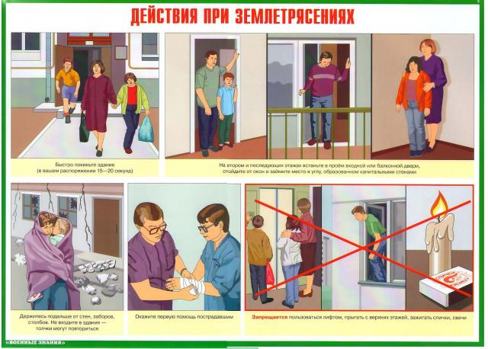](http://images.yandex.ru/yandsearch?text=%D0%BA%D0%B0%D1%80%D1%82%D0%B8%D0%BD%D0%BA%D0%B8%20%D0%BF%D0%BE%20%D1%87%D1%80%D0%B5%D0%B7%D0%B2%D1%8B%D1%87%D0%B0%D0%B9%D0%BD%D1%8B%D0%BC%20%D1%81%D0%B8%D1%82%D1%83%D0%B0%D1%86%D0%B8%D1%8F%D0%BC%20%D0%B4%D0%BB%D1%8F%20%D0%B4%D0%B5%D1%82%D0%B5%D0%B9%20%D0%B4%D0%B5%D0%B9%D1%81%D1%82%D0%B2%D0%B8%D1%8F%20%D0%BF%D1%80%D0%B8%20%D0%B7%D0%B5%D0%BC%D0%BB%D0%B5%D1%82%D1%80%D1%8F%D1%81%D0%B5%D0%BD%D0%B8%D0%B8&pos=1&uinfo=sw-1423-sh-805-fw-1198-fh-598-pd-1&rpt=simage&img_url=http://primamedia.ru/files/116885.jpg)

[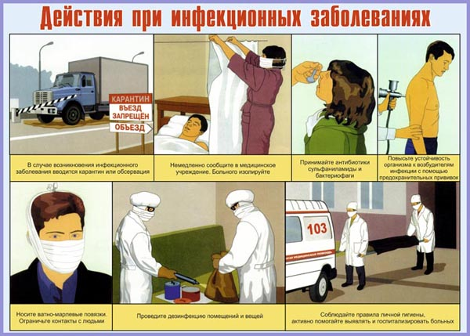](http://images.yandex.ru/yandsearch?text=%D0%BA%D0%B0%D1%80%D1%82%D0%B8%D0%BD%D0%BA%D0%B8%20%D0%BF%D0%BE%20%D1%87%D1%80%D0%B5%D0%B7%D0%B2%D1%8B%D1%87%D0%B0%D0%B9%D0%BD%D1%8B%D0%BC%20%D1%81%D0%B8%D1%82%D1%83%D0%B0%D1%86%D0%B8%D1%8F%D0%BC%20%D0%B4%D0%BB%D1%8F%20%D0%B4%D0%B5%D1%82%D0%B5%D0%B9%20%D0%B4%D0%B5%D0%B9%D1%81%D1%82%D0%B2%D0%B8%D1%8F%20%D0%BF%D1%80%D0%B8%20%D0%B8%D0%BD%D1%84%D0%B5%D0%BA%D1%86%D0%B8%D0%BE%D0%BD%D0%BD%D1%8B%D1%85%20%D0%B7%D0%B0%D0%B1%D0%BE%D0%BB%D0%B5%D0%B2%D0%B0%D0%BD%D0%B8%D1%8F%D1%85&pos=0&uinfo=sw-1423-sh-805-fw-1198-fh-598-pd-1&rpt=simage&img_url=http://www.st-dialog.ru/wp-content/uploads/chrezvychajnye-plakaty/07.jpg)

[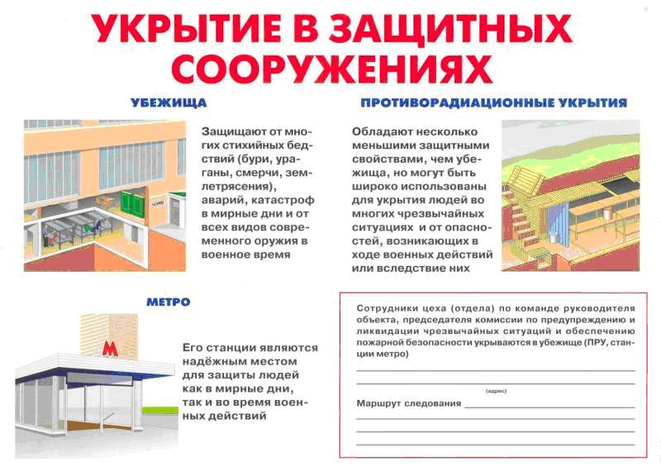](http://images.yandex.ru/yandsearch?source=wiz&uinfo=sw-1423-sh-805-fw-1198-fh-598-pd-1&p=7&text=%D0%BA%D0%B0%D1%80%D1%82%D0%B8%D0%BD%D0%BA%D0%B8%20%D0%BF%D0%BE%20%D1%87%D1%80%D0%B5%D0%B7%D0%B2%D1%8B%D1%87%D0%B0%D0%B9%D0%BD%D1%8B%D0%BC%20%D1%81%D0%B8%D1%82%D1%83%D0%B0%D1%86%D0%B8%D1%8F%D0%BC%20%D0%B4%D0%BB%D1%8F%20%D0%B4%D0%B5%D1%82%D0%B5%D0%B9&noreask=1&pos=229&rpt=simage&lr=54&img_url=http://www.ivanteevka.org/images/gochs/zashitnii_soorujeniya.jpg)

[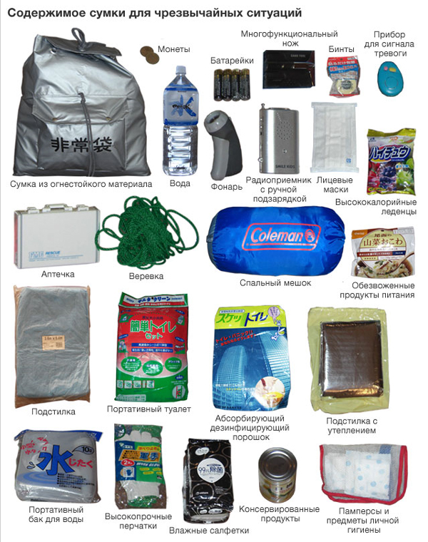](http://images.yandex.ru/yandsearch?source=wiz&uinfo=sw-1423-sh-805-fw-1198-fh-598-pd-1&p=9&text=%D0%BA%D0%B0%D1%80%D1%82%D0%B8%D0%BD%D0%BA%D0%B8%20%D0%BF%D0%BE%20%D1%87%D1%80%D0%B5%D0%B7%D0%B2%D1%8B%D1%87%D0%B0%D0%B9%D0%BD%D1%8B%D0%BC%20%D1%81%D0%B8%D1%82%D1%83%D0%B0%D1%86%D0%B8%D1%8F%D0%BC%20%D0%B4%D0%BB%D1%8F%20%D0%B4%D0%B5%D1%82%D0%B5%D0%B9&noreask=1&pos=278&rpt=simage&lr=54&img_url=http://forum.na-svyazi.ru/uploads/post-61518-1300511193.jpg)

[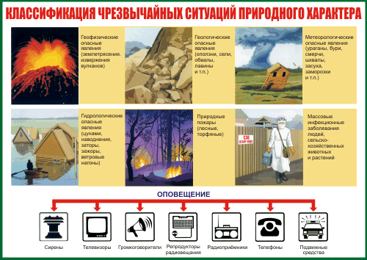](http://images.yandex.ru/yandsearch?text=%D0%BA%D0%B0%D1%80%D1%82%D0%B8%D0%BD%D0%BA%D0%B8%20%D0%BF%D0%BE%20%D1%87%D1%80%D0%B5%D0%B7%D0%B2%D1%8B%D1%87%D0%B0%D0%B9%D0%BD%D1%8B%D0%BC%20%D1%81%D0%B8%D1%82%D1%83%D0%B0%D1%86%D0%B8%D1%8F%D0%BC%20%D0%B4%D0%BB%D1%8F%20%D0%B4%D0%B5%D1%82%D0%B5%D0%B9%20%D0%B4%D0%B5%D0%B9%D1%81%D1%82%D0%B2%D0%B8%D1%8F%20%D0%BF%D1%80%D0%B8%20%D1%83%D1%80%D0%B0%D0%B3%D0%B0%D0%BD%D0%B5,%20%D1%81%D0%BC%D0%B5%D1%80%D1%87%D0%B5&pos=1&uinfo=sw-1423-sh-805-fw-1198-fh-598-pd-1&rpt=simage&img_url=http://survincity.ru/wp-content/uploads/2011-11-28/images4/deistviya_naseleniya_pri_stixiinix_bedstviyax_2.png)

[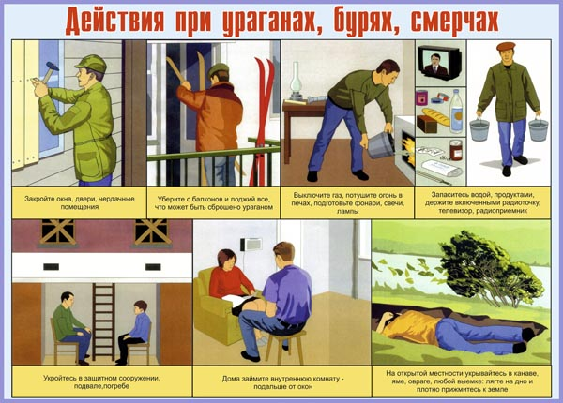](http://images.yandex.ru/yandsearch?text=%D0%BA%D0%B0%D1%80%D1%82%D0%B8%D0%BD%D0%BA%D0%B8%20%D0%BF%D0%BE%20%D1%87%D1%80%D0%B5%D0%B7%D0%B2%D1%8B%D1%87%D0%B0%D0%B9%D0%BD%D1%8B%D0%BC%20%D1%81%D0%B8%D1%82%D1%83%D0%B0%D1%86%D0%B8%D1%8F%D0%BC%20%D0%B4%D0%BB%D1%8F%20%D0%B4%D0%B5%D1%82%D0%B5%D0%B9%20%D0%B4%D0%B5%D0%B9%D1%81%D1%82%D0%B2%D0%B8%D1%8F%20%D0%BF%D1%80%D0%B8%20%D1%83%D1%80%D0%B0%D0%B3%D0%B0%D0%BD%D0%B5,%20%D1%81%D0%BC%D0%B5%D1%80%D1%87%D0%B5&pos=4&uinfo=sw-1423-sh-805-fw-1198-fh-598-pd-1&rpt=simage&img_url=http://www.st-dialog.ru/wp-content/uploads/chrezvychajnye-plakaty/17.jpg)

[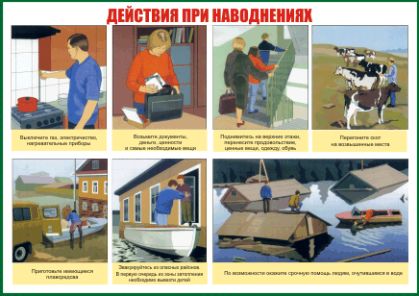](http://images.yandex.ru/yandsearch?text=%D0%BA%D0%B0%D1%80%D1%82%D0%B8%D0%BD%D0%BA%D0%B8%20%D0%BF%D0%BE%20%D1%87%D1%80%D0%B5%D0%B7%D0%B2%D1%8B%D1%87%D0%B0%D0%B9%D0%BD%D1%8B%D0%BC%20%D1%81%D0%B8%D1%82%D1%83%D0%B0%D1%86%D0%B8%D1%8F%D0%BC%20%D0%B4%D0%BB%D1%8F%20%D0%B4%D0%B5%D1%82%D0%B5%D0%B9%20%D0%B4%D0%B5%D0%B9%D1%81%D1%82%D0%B2%D0%B8%D1%8F%20%D0%BF%D1%80%D0%B8%20%D1%83%D1%80%D0%B0%D0%B3%D0%B0%D0%BD%D0%B5,%20%D1%81%D0%BC%D0%B5%D1%80%D1%87%D0%B5&pos=5&uinfo=sw-1423-sh-805-fw-1198-fh-598-pd-1&rpt=simage&img_url=http://www.gradremstroy.ru/images/oborud/6-1.png)

[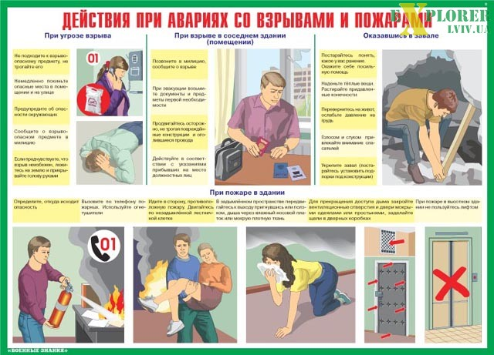](http://images.yandex.ru/yandsearch?source=wiz&uinfo=sw-1423-sh-805-fw-1198-fh-598-pd-1&p=12&text=%D0%BA%D0%B0%D1%80%D1%82%D0%B8%D0%BD%D0%BA%D0%B8%20%D0%BF%D0%BE%20%D1%87%D1%80%D0%B5%D0%B7%D0%B2%D1%8B%D1%87%D0%B0%D0%B9%D0%BD%D1%8B%D0%BC%20%D1%81%D0%B8%D1%82%D1%83%D0%B0%D1%86%D0%B8%D1%8F%D0%BC%20%D0%B4%D0%BB%D1%8F%20%D0%B4%D0%B5%D1%82%D0%B5%D0%B9&noreask=1&pos=368&rpt=simage&lr=54&img_url=http://wwww.starline.lg.ua/uploads/KOMPL1_08.jpg)

[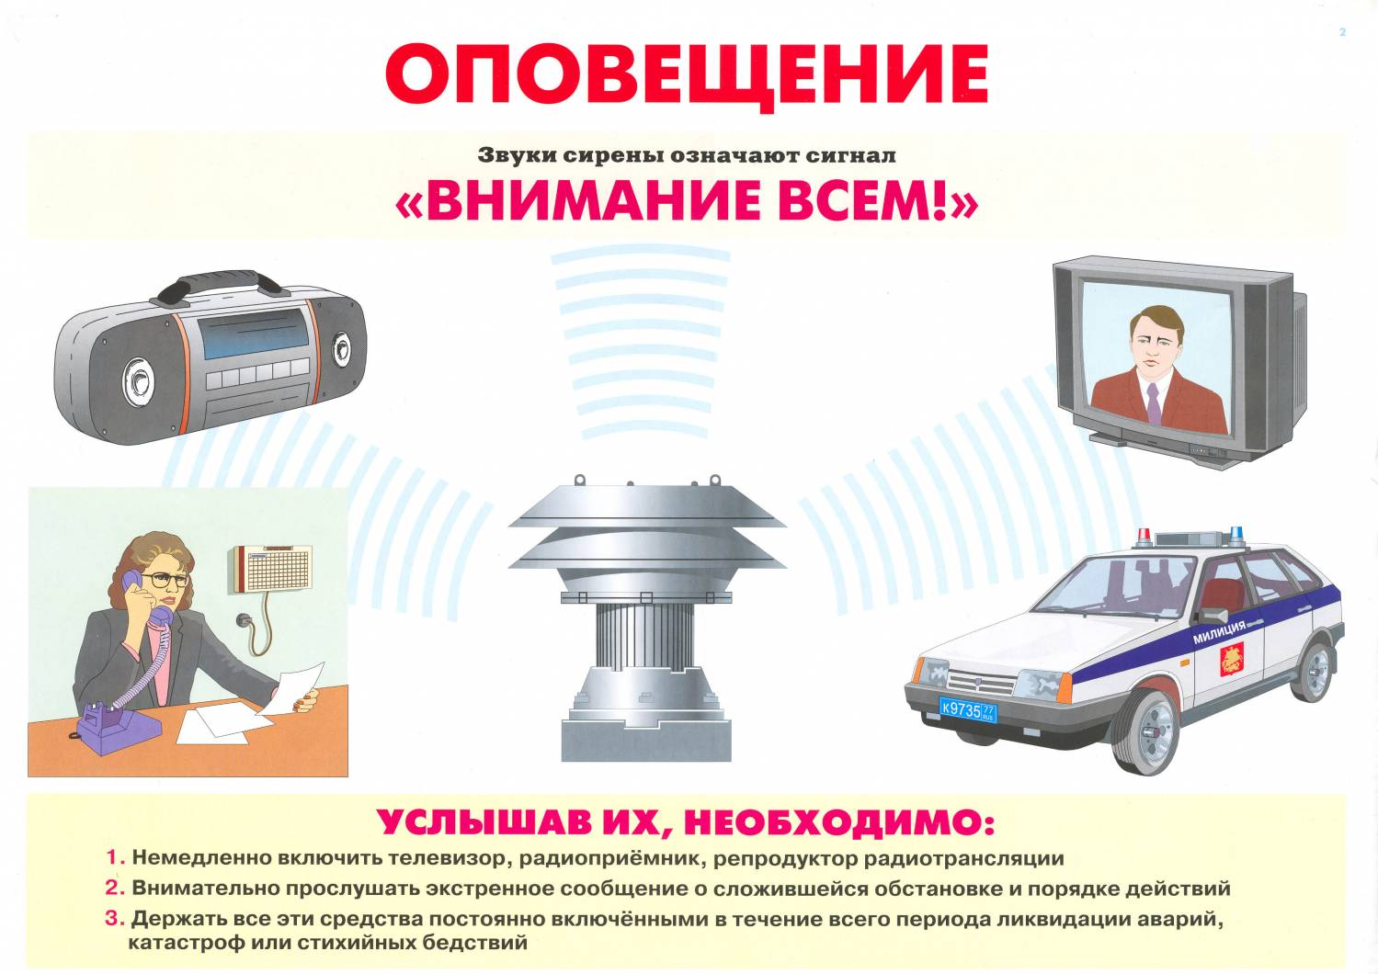](http://images.yandex.ru/yandsearch?source=wiz&uinfo=sw-1423-sh-805-fw-1198-fh-598-pd-1&p=12&text=%D0%BA%D0%B0%D1%80%D1%82%D0%B8%D0%BD%D0%BA%D0%B8%20%D0%BF%D0%BE%20%D1%87%D1%80%D0%B5%D0%B7%D0%B2%D1%8B%D1%87%D0%B0%D0%B9%D0%BD%D1%8B%D0%BC%20%D1%81%D0%B8%D1%82%D1%83%D0%B0%D1%86%D0%B8%D1%8F%D0%BC%20%D0%B4%D0%BB%D1%8F%20%D0%B4%D0%B5%D1%82%D0%B5%D0%B9&noreask=1&pos=384&rpt=simage&lr=54&img_url=http://www.68.mchs.gov.ru/upload/iblock/f9a/f9a67f9c0b9f044f6e7db6f592e7680e.jpg)

[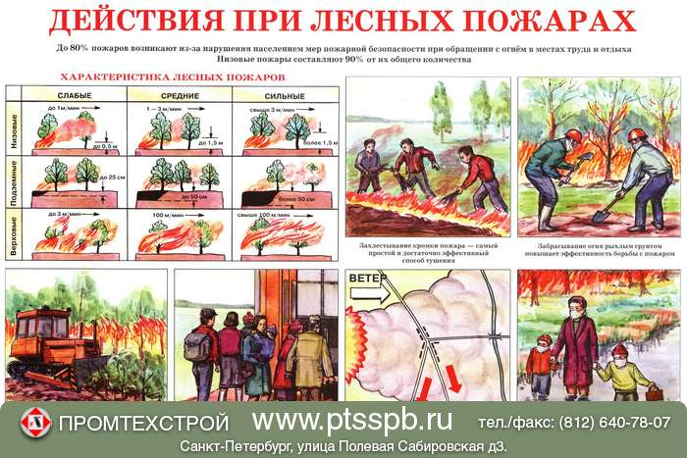](http://images.yandex.ru/yandsearch?text=%D0%BA%D0%B0%D1%80%D1%82%D0%B8%D0%BD%D0%BA%D0%B8%20%D0%BF%D0%BE%20%D1%87%D1%80%D0%B5%D0%B7%D0%B2%D1%8B%D1%87%D0%B0%D0%B9%D0%BD%D1%8B%D0%BC%20%D1%81%D0%B8%D1%82%D1%83%D0%B0%D1%86%D0%B8%D1%8F%D0%BC%20%D0%B4%D0%BB%D1%8F%20%D0%B4%D0%B5%D1%82%D0%B5%D0%B9%20%D0%B4%D0%B5%D0%B9%D1%81%D1%82%D0%B2%D0%B8%D1%8F%20%D0%BF%D1%80%D0%B8%20%D1%83%D1%80%D0%B0%D0%B3%D0%B0%D0%BD%D0%B5,%20%D1%81%D0%BC%D0%B5%D1%80%D1%87%D0%B5&pos=21&uinfo=sw-1423-sh-805-fw-1198-fh-598-pd-1&rpt=simage&img_url=http://www.pictureshack.ru/gthumbs/6425lesnye-pogary.jpg)

[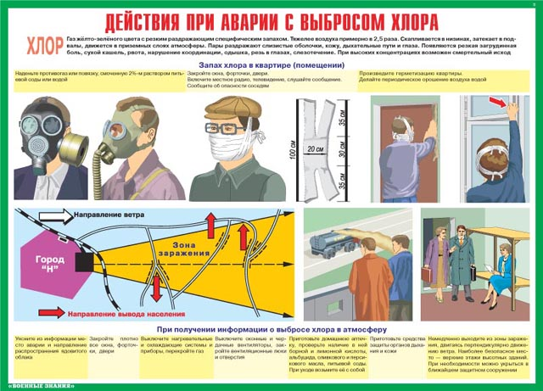](http://images.yandex.ru/yandsearch?source=wiz&uinfo=sw-1423-sh-805-fw-1198-fh-598-pd-1&p=26&text=%D0%BA%D0%B0%D1%80%D1%82%D0%B8%D0%BD%D0%BA%D0%B8%20%D0%BF%D0%BE%20%D1%87%D1%80%D0%B5%D0%B7%D0%B2%D1%8B%D1%87%D0%B0%D0%B9%D0%BD%D1%8B%D0%BC%20%D1%81%D0%B8%D1%82%D1%83%D0%B0%D1%86%D0%B8%D1%8F%D0%BC%20%D0%B4%D0%BB%D1%8F%20%D0%B4%D0%B5%D1%82%D0%B5%D0%B9&noreask=1&pos=781&rpt=simage&lr=54&img_url=http://www.obg.86sch-svetlyii.edusite.ru/images/53_280110.jpg)

[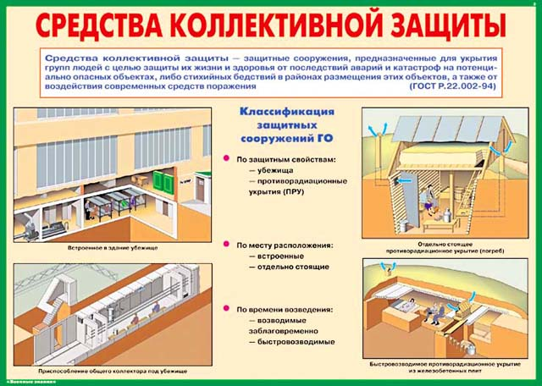](http://images.yandex.ru/yandsearch?source=wiz&uinfo=sw-1423-sh-805-fw-1198-fh-598-pd-1&p=43&text=%D0%BA%D0%B0%D1%80%D1%82%D0%B8%D0%BD%D0%BA%D0%B8%20%D0%BF%D0%BE%20%D1%87%D1%80%D0%B5%D0%B7%D0%B2%D1%8B%D1%87%D0%B0%D0%B9%D0%BD%D1%8B%D0%BC%20%D1%81%D0%B8%D1%82%D1%83%D0%B0%D1%86%D0%B8%D1%8F%D0%BC%20%D0%B4%D0%BB%D1%8F%20%D0%B4%D0%B5%D1%82%D0%B5%D0%B9&noreask=1&pos=1309&rpt=simage&lr=54&img_url=http://www.45.mchs.gov.ru/upload/images/GO5.jpg)