[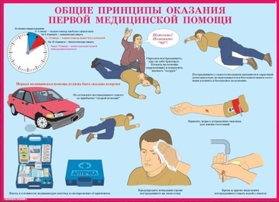](http://images.yandex.ru/yandsearch?p=1&text=%D0%BA%D0%B0%D1%80%D1%82%D0%B8%D0%BD%D0%BA%D0%B8%20%D0%BF%D0%B5%D1%80%D0%B2%D0%B0%D1%8F%20%D0%BC%D0%B5%D0%B4%D0%B8%D1%86%D0%B8%D0%BD%D1%81%D0%BA%D0%B0%D1%8F%20%D0%BF%D0%BE%D0%BC%D0%BE%D1%89%D1%8C%20%D0%BF%D1%80%D0%B8%20%D1%87%D1%80%D0%B5%D0%B7%D0%B2%D1%8B%D1%87%D0%B0%D0%B9%D0%BD%D1%8B%D1%85%20%D1%81%D0%B8%D1%82%D1%83%D0%B0%D1%86%D0%B8%D1%8F%D1%85&pos=46&uinfo=sw-1423-sh-805-fw-1198-fh-598-pd-1&rpt=simage&img_url=http://ecomastervlad.ru/d/20697/d/676201003_6.jpg)

[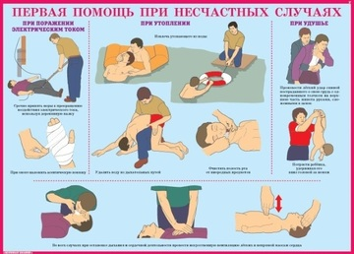](http://images.yandex.ru/yandsearch?p=1&text=%D0%BA%D0%B0%D1%80%D1%82%D0%B8%D0%BD%D0%BA%D0%B8%20%D0%BF%D0%B5%D1%80%D0%B2%D0%B0%D1%8F%20%D0%BC%D0%B5%D0%B4%D0%B8%D1%86%D0%B8%D0%BD%D1%81%D0%BA%D0%B0%D1%8F%20%D0%BF%D0%BE%D0%BC%D0%BE%D1%89%D1%8C%20%D0%BF%D1%80%D0%B8%20%D1%87%D1%80%D0%B5%D0%B7%D0%B2%D1%8B%D1%87%D0%B0%D0%B9%D0%BD%D1%8B%D1%85%20%D1%81%D0%B8%D1%82%D1%83%D0%B0%D1%86%D0%B8%D1%8F%D1%85&pos=42&uinfo=sw-1423-sh-805-fw-1198-fh-598-pd-1&rpt=simage&img_url=http://ecomastervlad.ru/d/20697/d/676202203_6.jpg)

[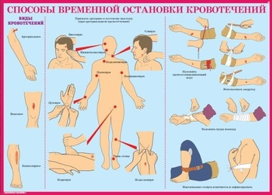](http://images.yandex.ru/yandsearch?p=1&text=%D0%BA%D0%B0%D1%80%D1%82%D0%B8%D0%BD%D0%BA%D0%B8%20%D0%BF%D0%B5%D1%80%D0%B2%D0%B0%D1%8F%20%D0%BC%D0%B5%D0%B4%D0%B8%D1%86%D0%B8%D0%BD%D1%81%D0%BA%D0%B0%D1%8F%20%D0%BF%D0%BE%D0%BC%D0%BE%D1%89%D1%8C%20%D0%BF%D1%80%D0%B8%20%D1%87%D1%80%D0%B5%D0%B7%D0%B2%D1%8B%D1%87%D0%B0%D0%B9%D0%BD%D1%8B%D1%85%20%D1%81%D0%B8%D1%82%D1%83%D0%B0%D1%86%D0%B8%D1%8F%D1%85&pos=43&uinfo=sw-1423-sh-805-fw-1198-fh-598-pd-1&rpt=simage&img_url=http://ecomastervlad.ru/d/20697/d/676201603_6.jpg)

[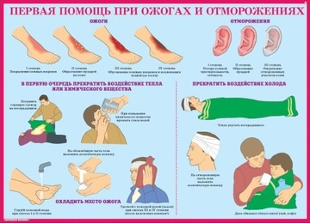](http://images.yandex.ru/yandsearch?p=1&text=%D0%BA%D0%B0%D1%80%D1%82%D0%B8%D0%BD%D0%BA%D0%B8%20%D0%BF%D0%B5%D1%80%D0%B2%D0%B0%D1%8F%20%D0%BC%D0%B5%D0%B4%D0%B8%D1%86%D0%B8%D0%BD%D1%81%D0%BA%D0%B0%D1%8F%20%D0%BF%D0%BE%D0%BC%D0%BE%D1%89%D1%8C%20%D0%BF%D1%80%D0%B8%20%D1%87%D1%80%D0%B5%D0%B7%D0%B2%D1%8B%D1%87%D0%B0%D0%B9%D0%BD%D1%8B%D1%85%20%D1%81%D0%B8%D1%82%D1%83%D0%B0%D1%86%D0%B8%D1%8F%D1%85&pos=44&uinfo=sw-1423-sh-805-fw-1198-fh-598-pd-1&rpt=simage&img_url=http://ecomastervlad.ru/d/20697/d/676202003_6.jpg)

[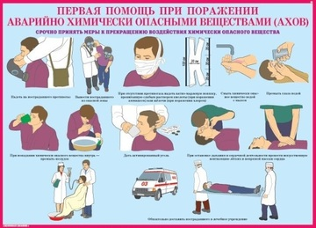](http://images.yandex.ru/yandsearch?p=1&text=%D0%BA%D0%B0%D1%80%D1%82%D0%B8%D0%BD%D0%BA%D0%B8%20%D0%BF%D0%B5%D1%80%D0%B2%D0%B0%D1%8F%20%D0%BC%D0%B5%D0%B4%D0%B8%D1%86%D0%B8%D0%BD%D1%81%D0%BA%D0%B0%D1%8F%20%D0%BF%D0%BE%D0%BC%D0%BE%D1%89%D1%8C%20%D0%BF%D1%80%D0%B8%20%D1%87%D1%80%D0%B5%D0%B7%D0%B2%D1%8B%D1%87%D0%B0%D0%B9%D0%BD%D1%8B%D1%85%20%D1%81%D0%B8%D1%82%D1%83%D0%B0%D1%86%D0%B8%D1%8F%D1%85&pos=45&uinfo=sw-1423-sh-805-fw-1198-fh-598-pd-1&rpt=simage&img_url=http://ecomastervlad.ru/d/20697/d/676202403_6.jpg)

[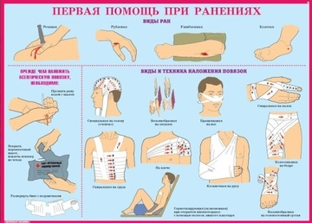](http://images.yandex.ru/yandsearch?p=1&text=%D0%BA%D0%B0%D1%80%D1%82%D0%B8%D0%BD%D0%BA%D0%B8%20%D0%BF%D0%B5%D1%80%D0%B2%D0%B0%D1%8F%20%D0%BC%D0%B5%D0%B4%D0%B8%D1%86%D0%B8%D0%BD%D1%81%D0%BA%D0%B0%D1%8F%20%D0%BF%D0%BE%D0%BC%D0%BE%D1%89%D1%8C%20%D0%BF%D1%80%D0%B8%20%D1%87%D1%80%D0%B5%D0%B7%D0%B2%D1%8B%D1%87%D0%B0%D0%B9%D0%BD%D1%8B%D1%85%20%D1%81%D0%B8%D1%82%D1%83%D0%B0%D1%86%D0%B8%D1%8F%D1%85&pos=47&uinfo=sw-1423-sh-805-fw-1198-fh-598-pd-1&rpt=simage&img_url=http://ecomastervlad.ru/d/20697/d/676201403_6.jpg)

[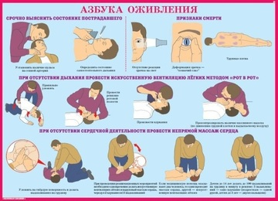](http://images.yandex.ru/yandsearch?p=1&text=%D0%BA%D0%B0%D1%80%D1%82%D0%B8%D0%BD%D0%BA%D0%B8%20%D0%BF%D0%B5%D1%80%D0%B2%D0%B0%D1%8F%20%D0%BC%D0%B5%D0%B4%D0%B8%D1%86%D0%B8%D0%BD%D1%81%D0%BA%D0%B0%D1%8F%20%D0%BF%D0%BE%D0%BC%D0%BE%D1%89%D1%8C%20%D0%BF%D1%80%D0%B8%20%D1%87%D1%80%D0%B5%D0%B7%D0%B2%D1%8B%D1%87%D0%B0%D0%B9%D0%BD%D1%8B%D1%85%20%D1%81%D0%B8%D1%82%D1%83%D0%B0%D1%86%D0%B8%D1%8F%D1%85&pos=48&uinfo=sw-1423-sh-805-fw-1198-fh-598-pd-1&rpt=simage&img_url=http://ecomastervlad.ru/d/20697/d/676201203_6.jpg)

[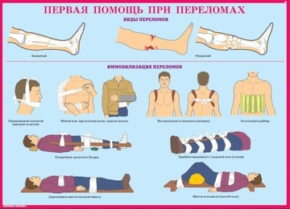](http://images.yandex.ru/yandsearch?p=1&text=%D0%BA%D0%B0%D1%80%D1%82%D0%B8%D0%BD%D0%BA%D0%B8%20%D0%BF%D0%B5%D1%80%D0%B2%D0%B0%D1%8F%20%D0%BC%D0%B5%D0%B4%D0%B8%D1%86%D0%B8%D0%BD%D1%81%D0%BA%D0%B0%D1%8F%20%D0%BF%D0%BE%D0%BC%D0%BE%D1%89%D1%8C%20%D0%BF%D1%80%D0%B8%20%D1%87%D1%80%D0%B5%D0%B7%D0%B2%D1%8B%D1%87%D0%B0%D0%B9%D0%BD%D1%8B%D1%85%20%D1%81%D0%B8%D1%82%D1%83%D0%B0%D1%86%D0%B8%D1%8F%D1%85&pos=49&uinfo=sw-1423-sh-805-fw-1198-fh-598-pd-1&rpt=simage&img_url=http://ecomastervlad.ru/d/20697/d/676201803_6.jpg)

[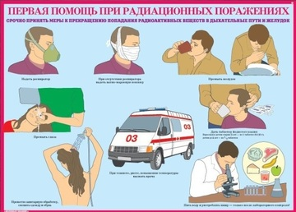](http://images.yandex.ru/yandsearch?p=1&text=%D0%BA%D0%B0%D1%80%D1%82%D0%B8%D0%BD%D0%BA%D0%B8%20%D0%BF%D0%B5%D1%80%D0%B2%D0%B0%D1%8F%20%D0%BC%D0%B5%D0%B4%D0%B8%D1%86%D0%B8%D0%BD%D1%81%D0%BA%D0%B0%D1%8F%20%D0%BF%D0%BE%D0%BC%D0%BE%D1%89%D1%8C%20%D0%BF%D1%80%D0%B8%20%D1%87%D1%80%D0%B5%D0%B7%D0%B2%D1%8B%D1%87%D0%B0%D0%B9%D0%BD%D1%8B%D1%85%20%D1%81%D0%B8%D1%82%D1%83%D0%B0%D1%86%D0%B8%D1%8F%D1%85&pos=50&uinfo=sw-1423-sh-805-fw-1198-fh-598-pd-1&rpt=simage&img_url=http://ecomastervlad.ru/d/20697/d/676202603_6.jpg)

[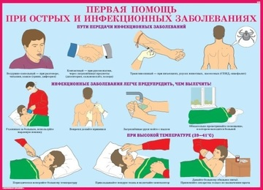](http://images.yandex.ru/yandsearch?p=1&text=%D0%BA%D0%B0%D1%80%D1%82%D0%B8%D0%BD%D0%BA%D0%B8%20%D0%BF%D0%B5%D1%80%D0%B2%D0%B0%D1%8F%20%D0%BC%D0%B5%D0%B4%D0%B8%D1%86%D0%B8%D0%BD%D1%81%D0%BA%D0%B0%D1%8F%20%D0%BF%D0%BE%D0%BC%D0%BE%D1%89%D1%8C%20%D0%BF%D1%80%D0%B8%20%D1%87%D1%80%D0%B5%D0%B7%D0%B2%D1%8B%D1%87%D0%B0%D0%B9%D0%BD%D1%8B%D1%85%20%D1%81%D0%B8%D1%82%D1%83%D0%B0%D1%86%D0%B8%D1%8F%D1%85&pos=51&uinfo=sw-1423-sh-805-fw-1198-fh-598-pd-1&rpt=simage&img_url=http://ecomastervlad.ru/d/20697/d/676202803_6.jpg)

[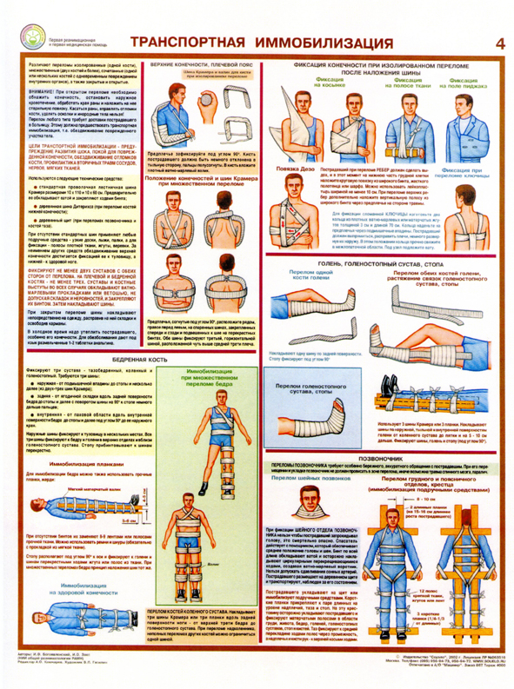](http://images.yandex.ru/yandsearch?source=wiz&uinfo=sw-1423-sh-805-fw-1198-fh-598-pd-1&p=38&text=%D0%BA%D0%B0%D1%80%D1%82%D0%B8%D0%BD%D0%BA%D0%B8%20%D0%BF%D0%BE%20%D1%87%D1%80%D0%B5%D0%B7%D0%B2%D1%8B%D1%87%D0%B0%D0%B9%D0%BD%D1%8B%D0%BC%20%D1%81%D0%B8%D1%82%D1%83%D0%B0%D1%86%D0%B8%D1%8F%D0%BC%20%D0%B4%D0%BB%D1%8F%20%D0%B4%D0%B5%D1%82%D0%B5%D0%B9&noreask=1&pos=1162&rpt=simage&lr=54&img_url=http://voennizdat.com/plakatu/VMP/Plvmp10.jpg)

[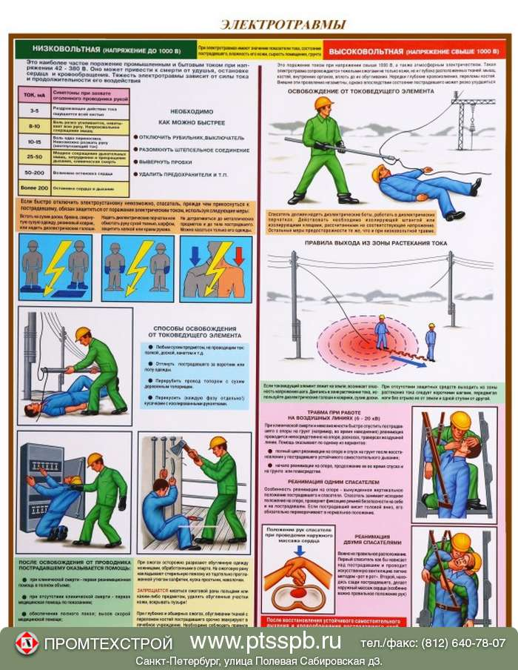](http://images.yandex.ru/yandsearch?text=%D0%BA%D0%B0%D1%80%D1%82%D0%B8%D0%BD%D0%BA%D0%B8%20%D0%BF%D0%B5%D1%80%D0%B2%D0%B0%D1%8F%20%D0%BC%D0%B5%D0%B4%D0%B8%D1%86%D0%B8%D0%BD%D1%81%D0%BA%D0%B0%D1%8F%20%D0%BF%D0%BE%D0%BC%D0%BE%D1%89%D1%8C%20%D0%BF%D1%80%D0%B8%20%D1%8D%D0%BB%D0%B5%D0%BA%D1%82%D1%80%D0%BE%D1%82%D1%80%D0%B0%D0%B2%D0%BC%D0%B5&pos=2&uinfo=sw-1423-sh-805-fw-1198-fh-598-pd-1&rpt=simage&img_url=http://cs13.babysfera.ru/e/3/c/f/10542974.59318514.jpeg)