[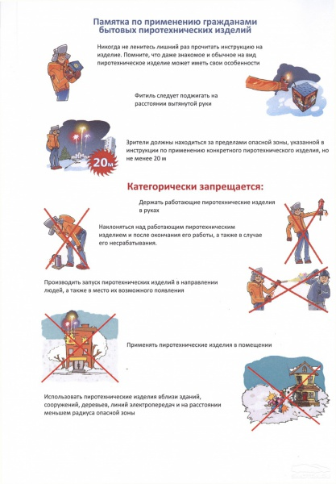](http://images.yandex.ru/yandsearch?source=wiz&uinfo=sw-1423-sh-805-fw-1198-fh-598-pd-1&p=25&text=%D0%BA%D0%B0%D1%80%D1%82%D0%B8%D0%BD%D0%BA%D0%B8%20%D0%BF%D0%BE%20%D1%87%D1%80%D0%B5%D0%B7%D0%B2%D1%8B%D1%87%D0%B0%D0%B9%D0%BD%D1%8B%D0%BC%20%D1%81%D0%B8%D1%82%D1%83%D0%B0%D1%86%D0%B8%D1%8F%D0%BC%20%D0%B4%D0%BB%D1%8F%20%D0%B4%D0%B5%D1%82%D0%B5%D0%B9&noreask=1&pos=774&rpt=simage&lr=54&img_url=http://www.36.mchs.gov.ru/upload/salekhard/voronegh/pamyatka.jpg)